**Deploy applications on AWS EKS**

**1.** **Prerequisites** 2

**2.** **Setup infrastructure with Terraform** 2

**2.1. Set up AWS credential configure** 2

**2.2. Initialize the module** 2

**2.3. Verify the terraform plan** 4

**2.3.1. Verify Cluster using kubectl** 4

**2.3.2. Verify on AWS UI** 4

**3.** **Setup Jenkins server with Terraform** 7

**3.1. Initialize the module** 7

**3.2. Verify the terraform plan** 8

**3.3. Setup Jenkins account** 9

**4.** **Setup Jenkins pipeline (Push images to AWS ACR)** 10

**5.** **EKS Setup** 14

**6.** **Monitoring with Prometheus and Grafana** 14

1. **Prerequisites**

* AWS account (IAM user)
* AWS CLI
* Terraform
* Docker
* Kubectl
* Eksctl
* Helm

1. **Setup infrastructure with Terraform**

**2.1. Set up AWS credential configure**

**-** Run the command to set up your AWS CLI: aws configure

**-** Enter the access key of your IAM account, if you already configured press enter.

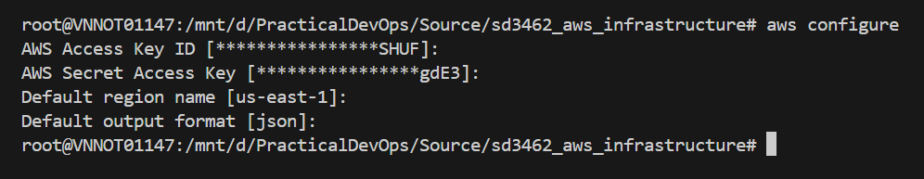

**2.2. Initialize the module**

**-** Move to the **“./eks-deploy/terraform”** directory to perform commands.

**-** Create the s3 bucket to store the *tfstate* file.

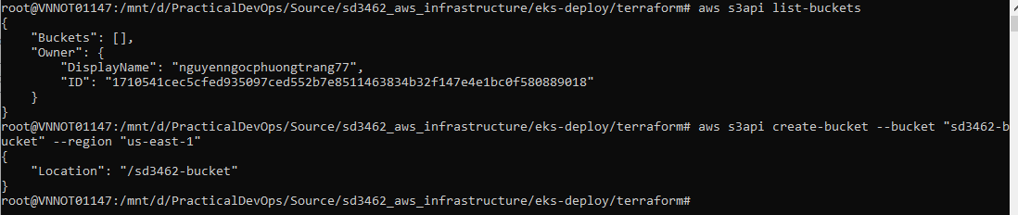

**-** Run the command terraform init -backend-config "key=${tfstate_file_name}" -backend-config "bucket=${tfstate_bucket_name}" -backend-config "region=us-east-1" to initializing the backend.

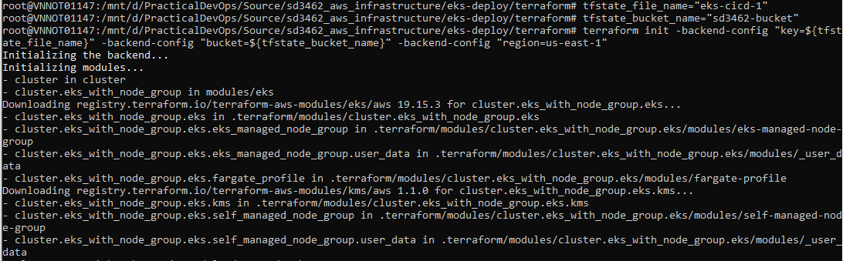

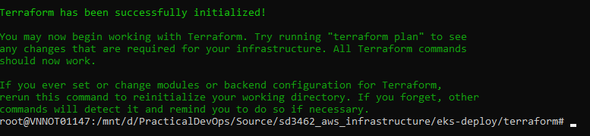

**-** After successfully initializing, run terraform validate to check whether the configuration is valid to ensure no issue when applying the terraform plan.



**-** Run terraform plan -var-file=”dev.tfvars” to apply the execution plan.

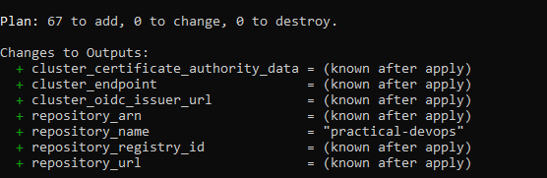

- Run terraform apply –var-file=”dev.tfvars” to create all the resource.

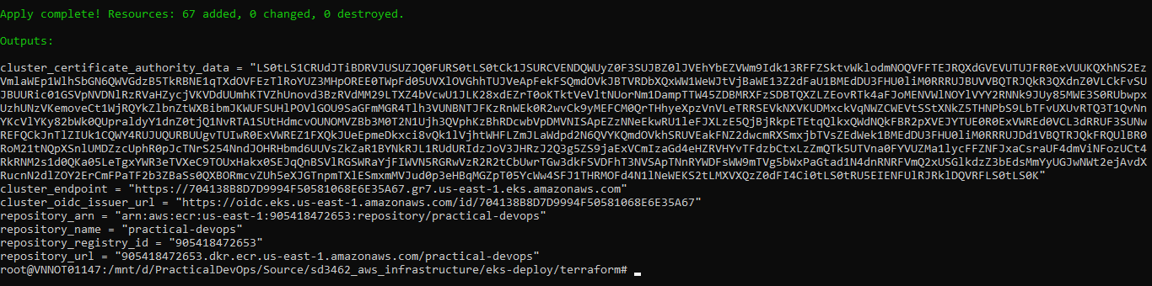

**2.3. Verify the terraform plan**

**2.3.1. Verify Cluster using kubectl**

- Check status of the Cluster aws eks --region us-east-1 describe-cluster --name devops-eks --query cluster.status.

- Configure kubectl with EKS API server credentials aws eks update-kubeconfig --region us-east-1 --name devops-eks.

- Check if you are pointing to the right kubernetes cluster kubectl config current-context



- Validate kubectl configuration master node.

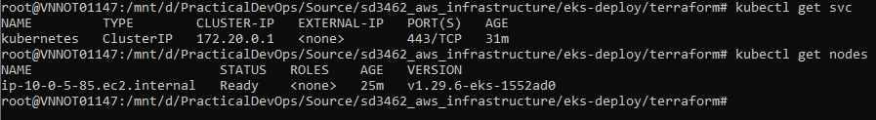

**2.3.2. Verify on AWS UI**

* S3 bucket.

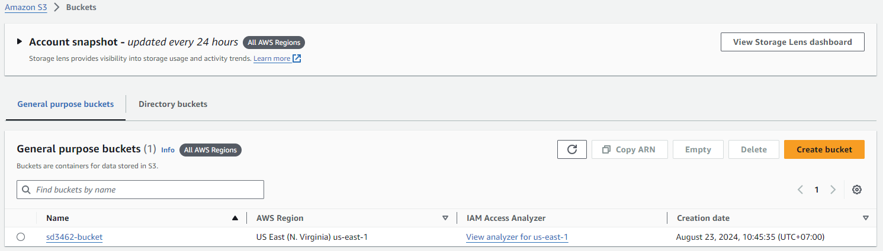

* Virtual private cloud.

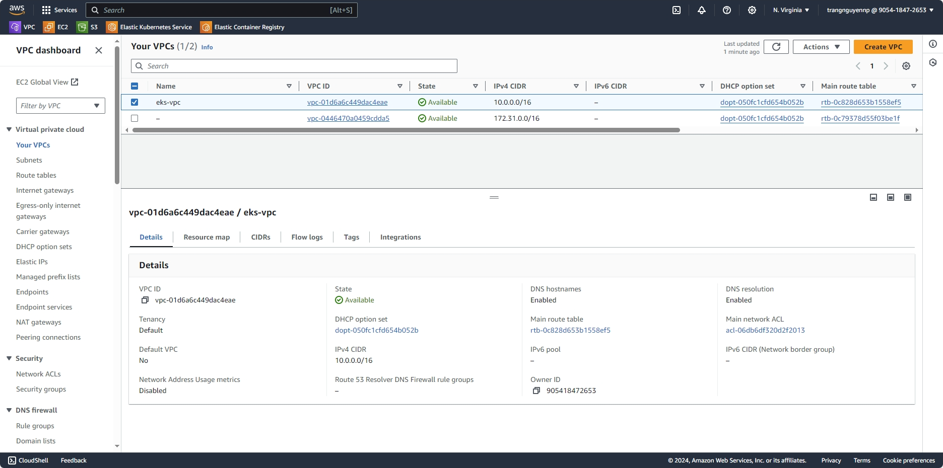

* EKS Cluster with OIDC Provider.

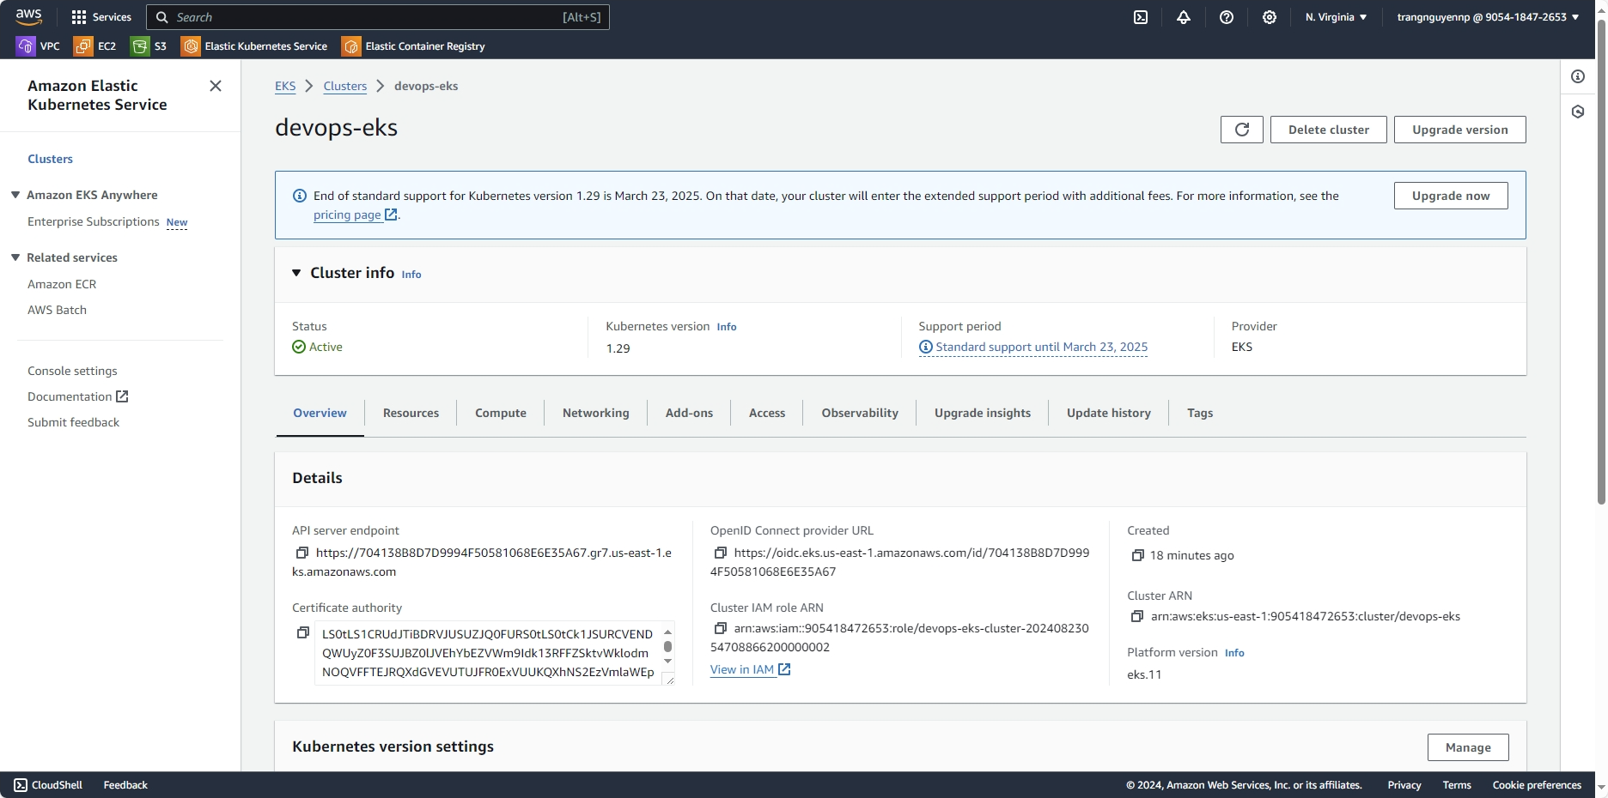

* EKS Managed AddOns.

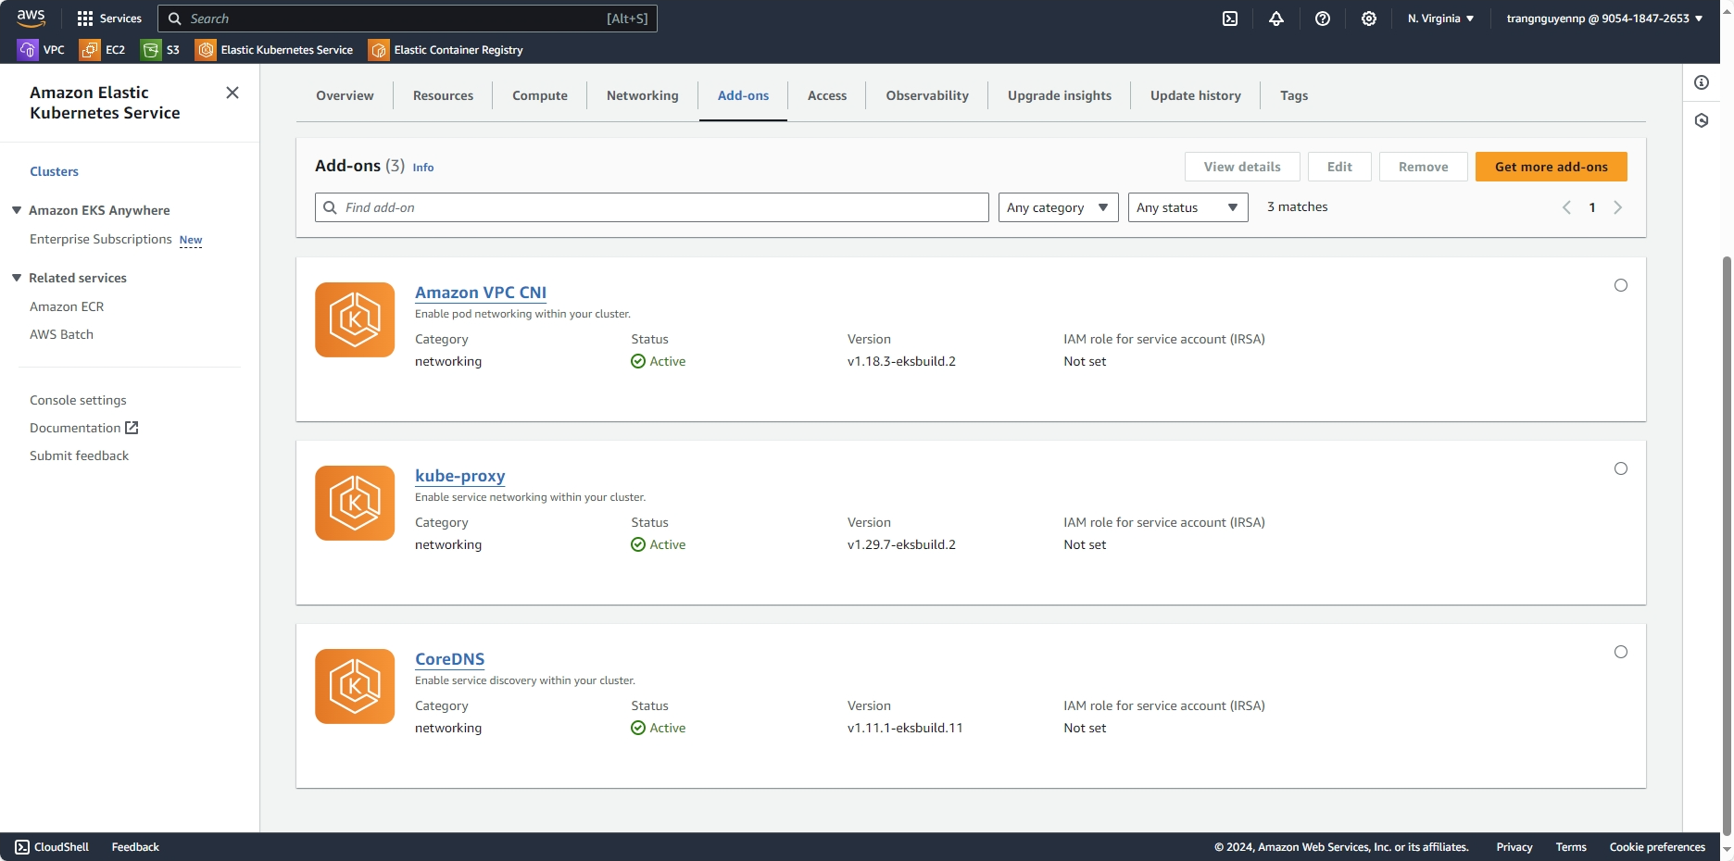

* EKS Managed node group.

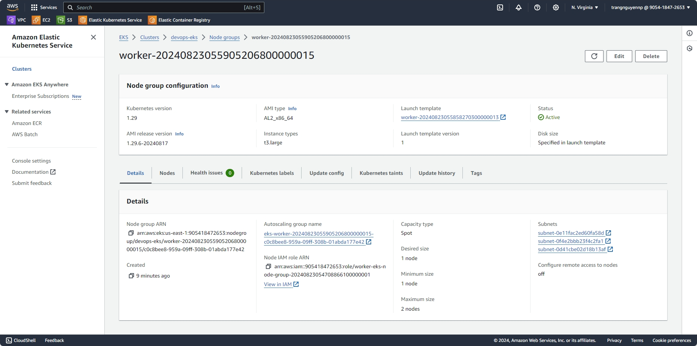

* EC2: worker nodes

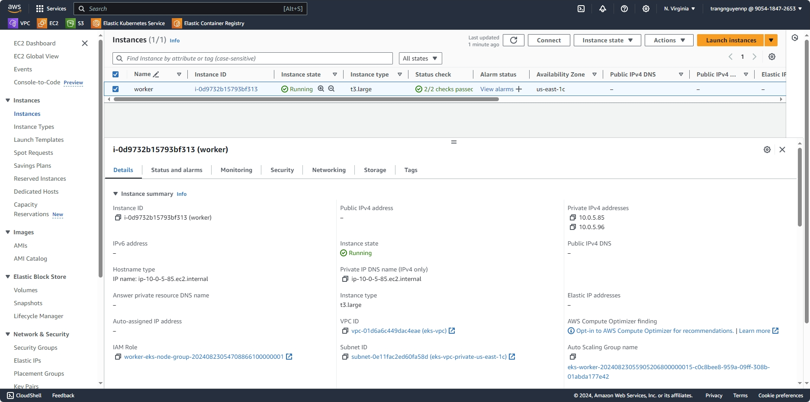

* ECR repositories

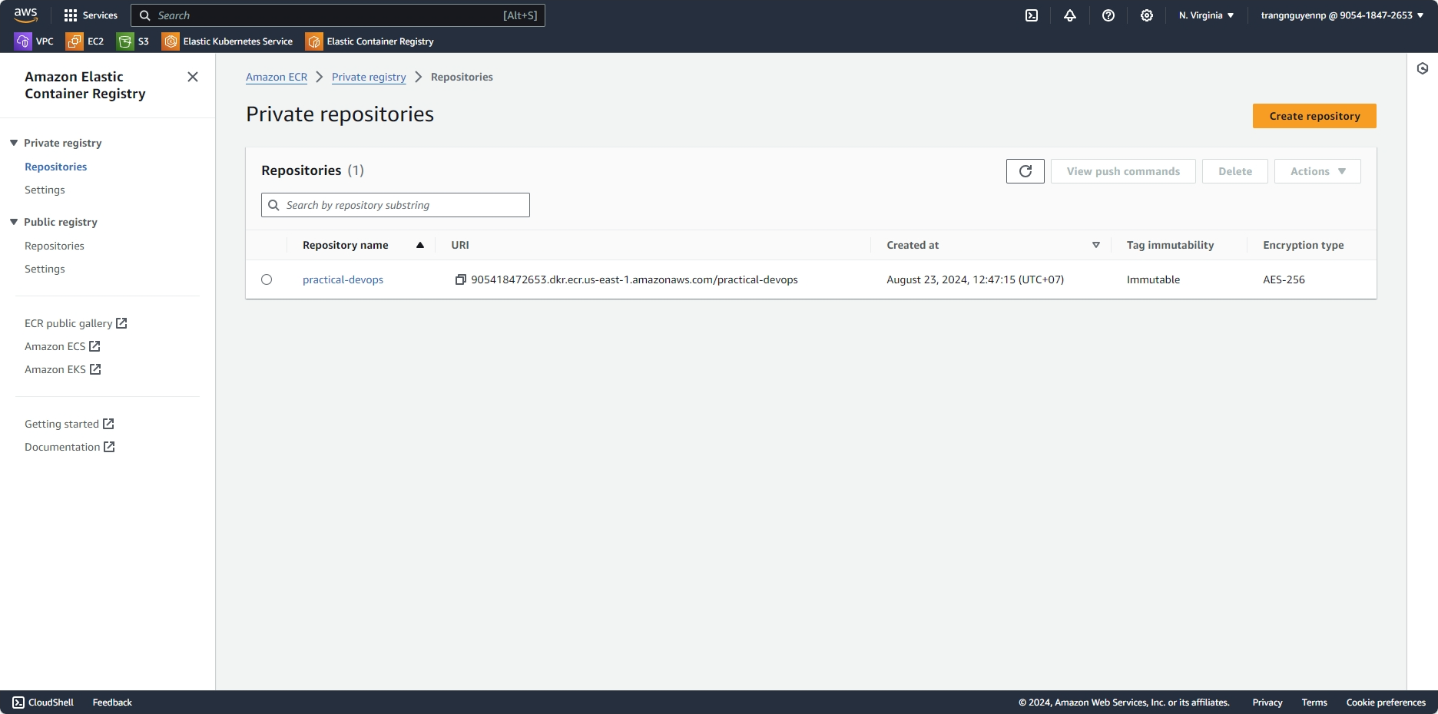

# **Setup Jenkins server with Terraform**

## **3.1. Initialize the module**

- Go to AWS UI page, create new key pair name **“jenkins-server-key”** in EC2 page.

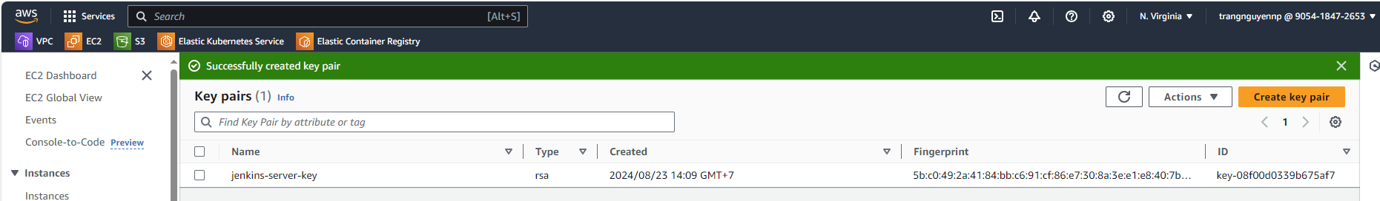

- Move to the **“./jenkins-server”** directory to perform commands.

- Run the command terraform init to initialize backend.

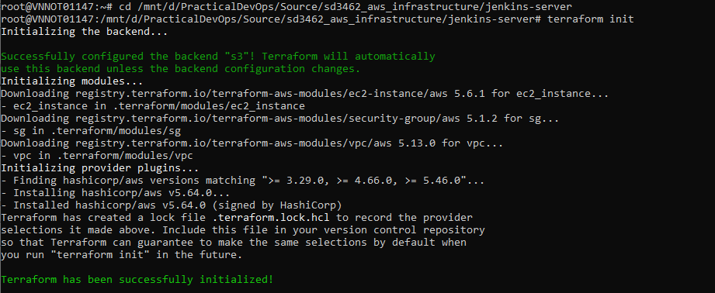

- After successfully initializing, run terraform validate to check whether the configuration is valid to ensure no issue when applying the terraform plan.

- Run terraform plan -var-file=”dev.tfvars” to apply the execution plan.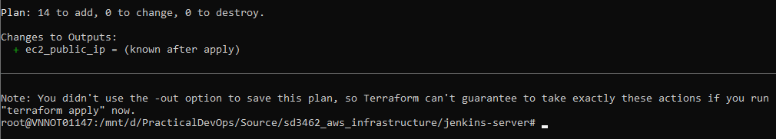

- Run terraform apply -var-file=”dev.tfvars” to create all the resource.

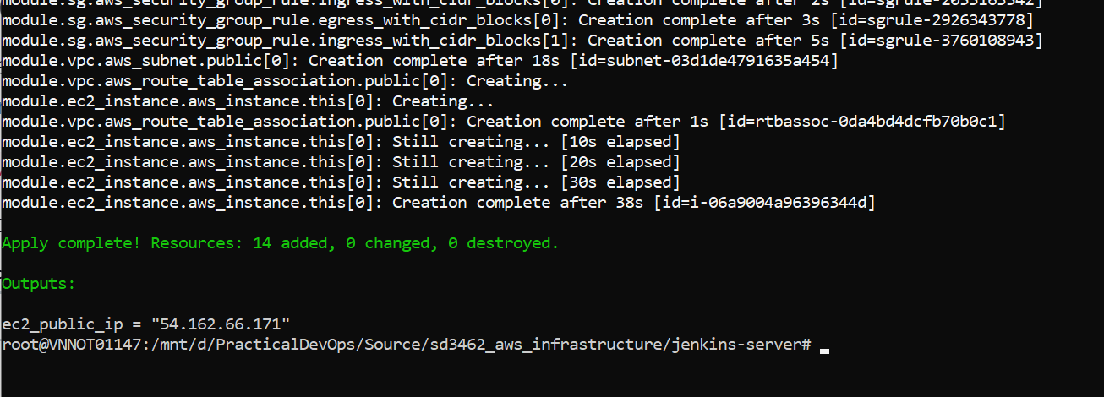

## **3.2. Verify the terraform plan**

- On EC2 page you will see the **jenkins-server** instance created.

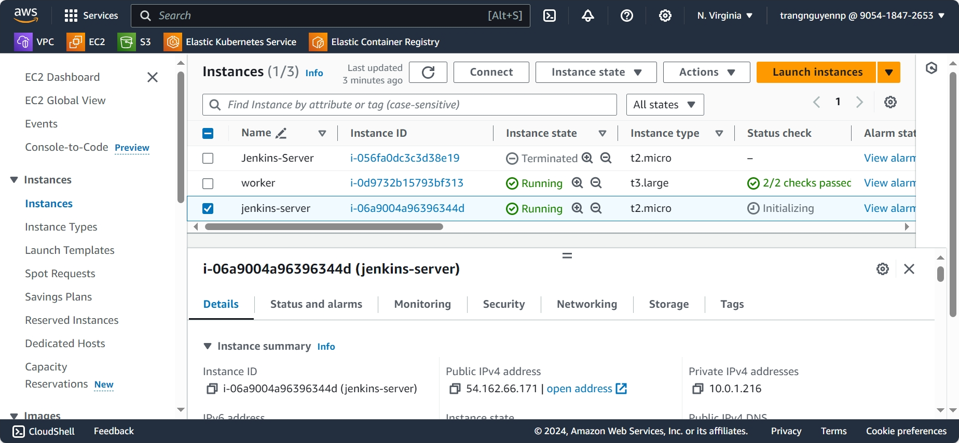

- Open address <http://ec2-public-ip:8080> to start the Jenkins.

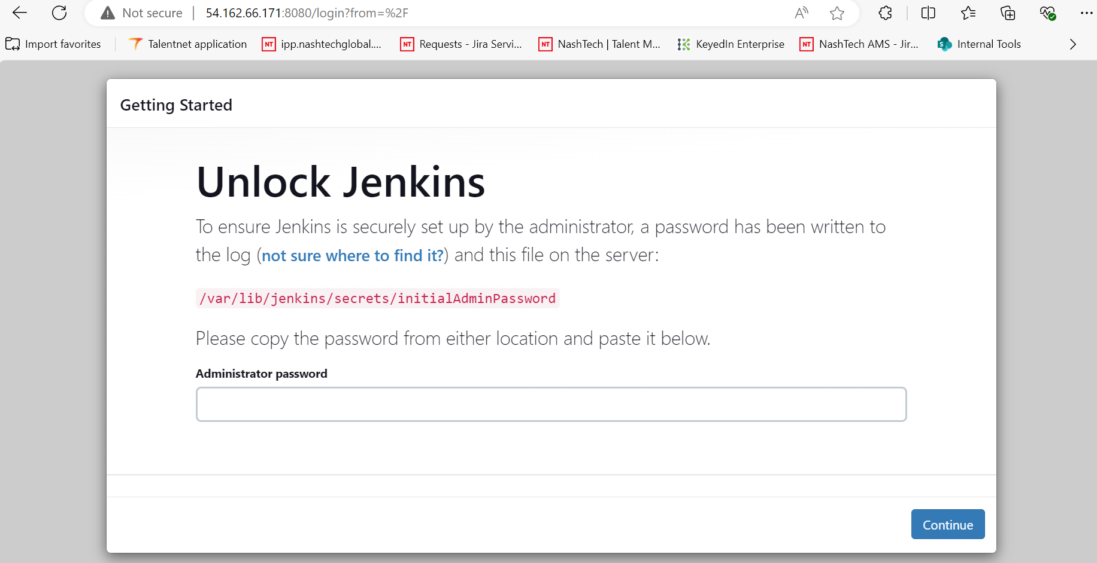

## **3.3. Setup Jenkins account**

- Following the getting started page to get the administrator password then setup your own username and password.

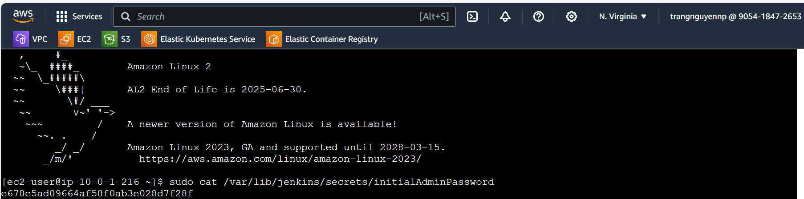

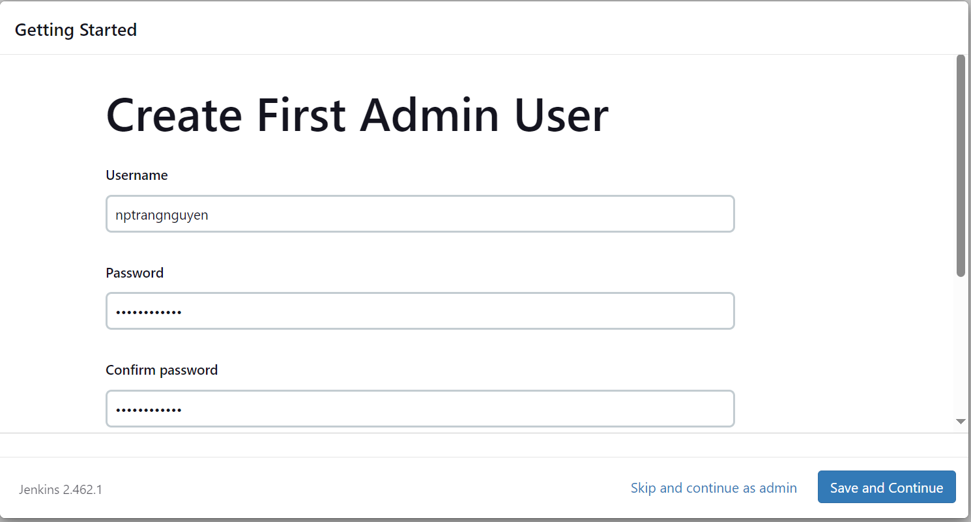

1. **Setup Jenkins pipeline (Push images to AWS ACR)**

* Add webhook for git repository. Click on **Repository settings** > **Webhook** and click **Add webhook.**

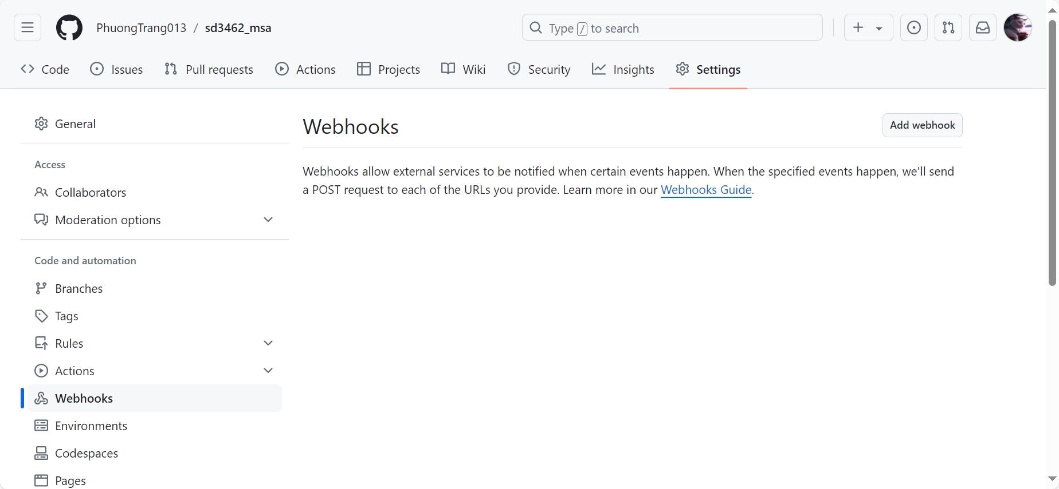

* Give a name to webhook > paste the url of the jenkins in the url section > click on generate secret > create webhook.

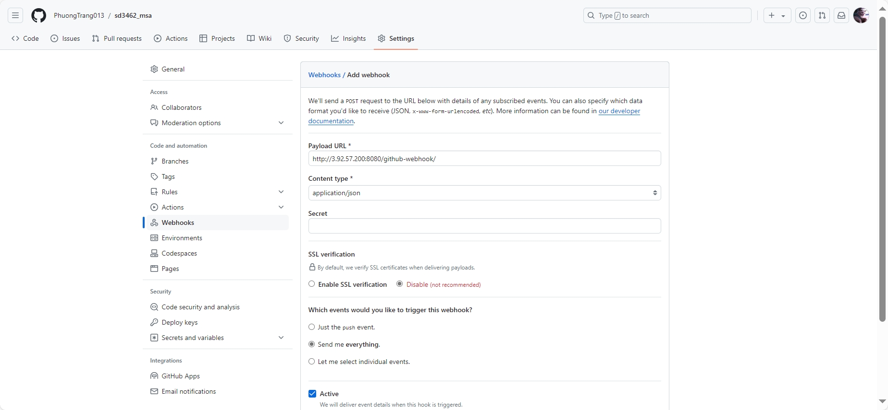

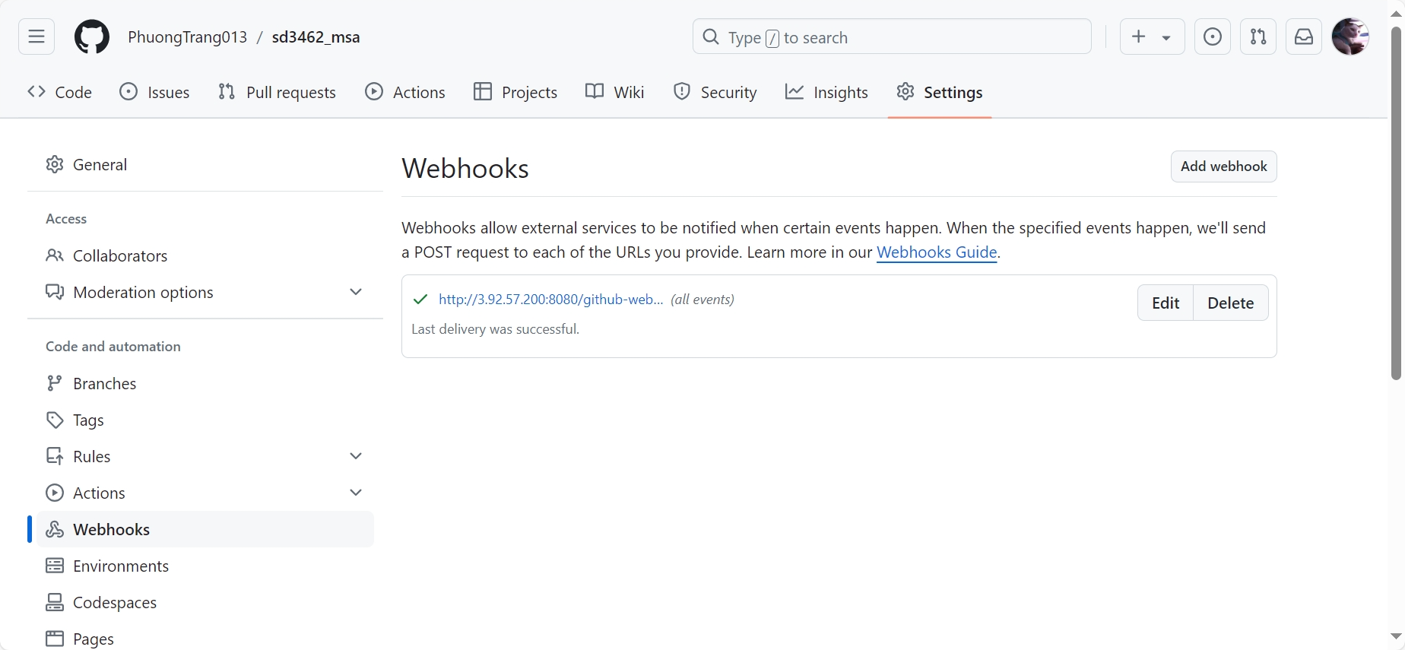

* On jenkins install necessary plugins to run docker and kubernetes commands.(docker, docker pipeline, amazon ecr )

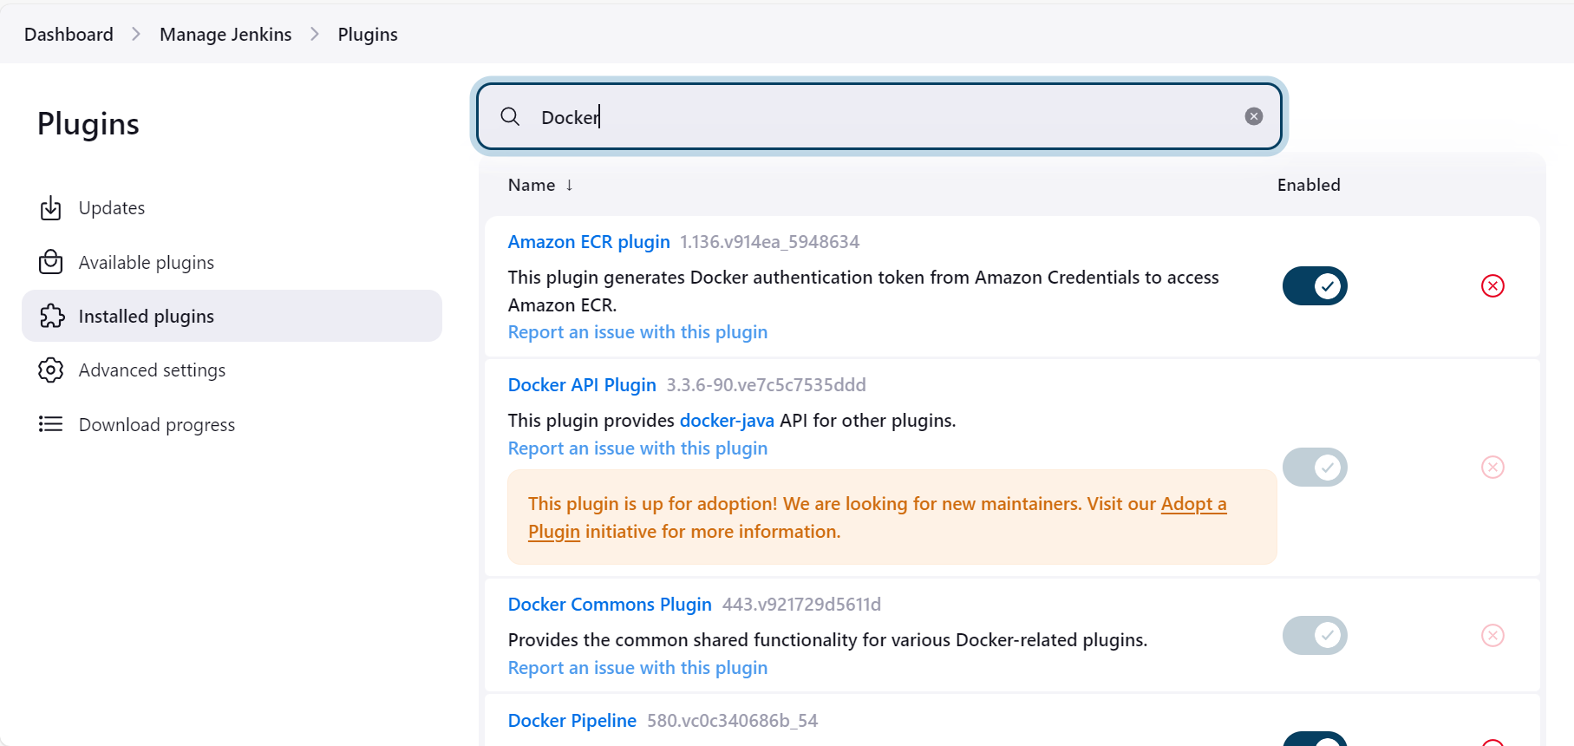

* Create IAM Role, go to **IAM** page and click **Create Role.** At select **trusted entity section**, choose **AWS service** for trusted type and **EC2** for the use case then click **Next**.

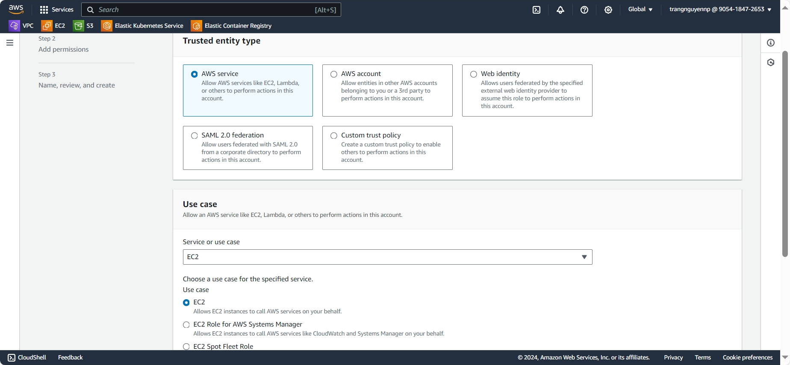

* On Add permissions section, add **AmazonEC2ContainerRegistryFullAccess** then click **Next**.

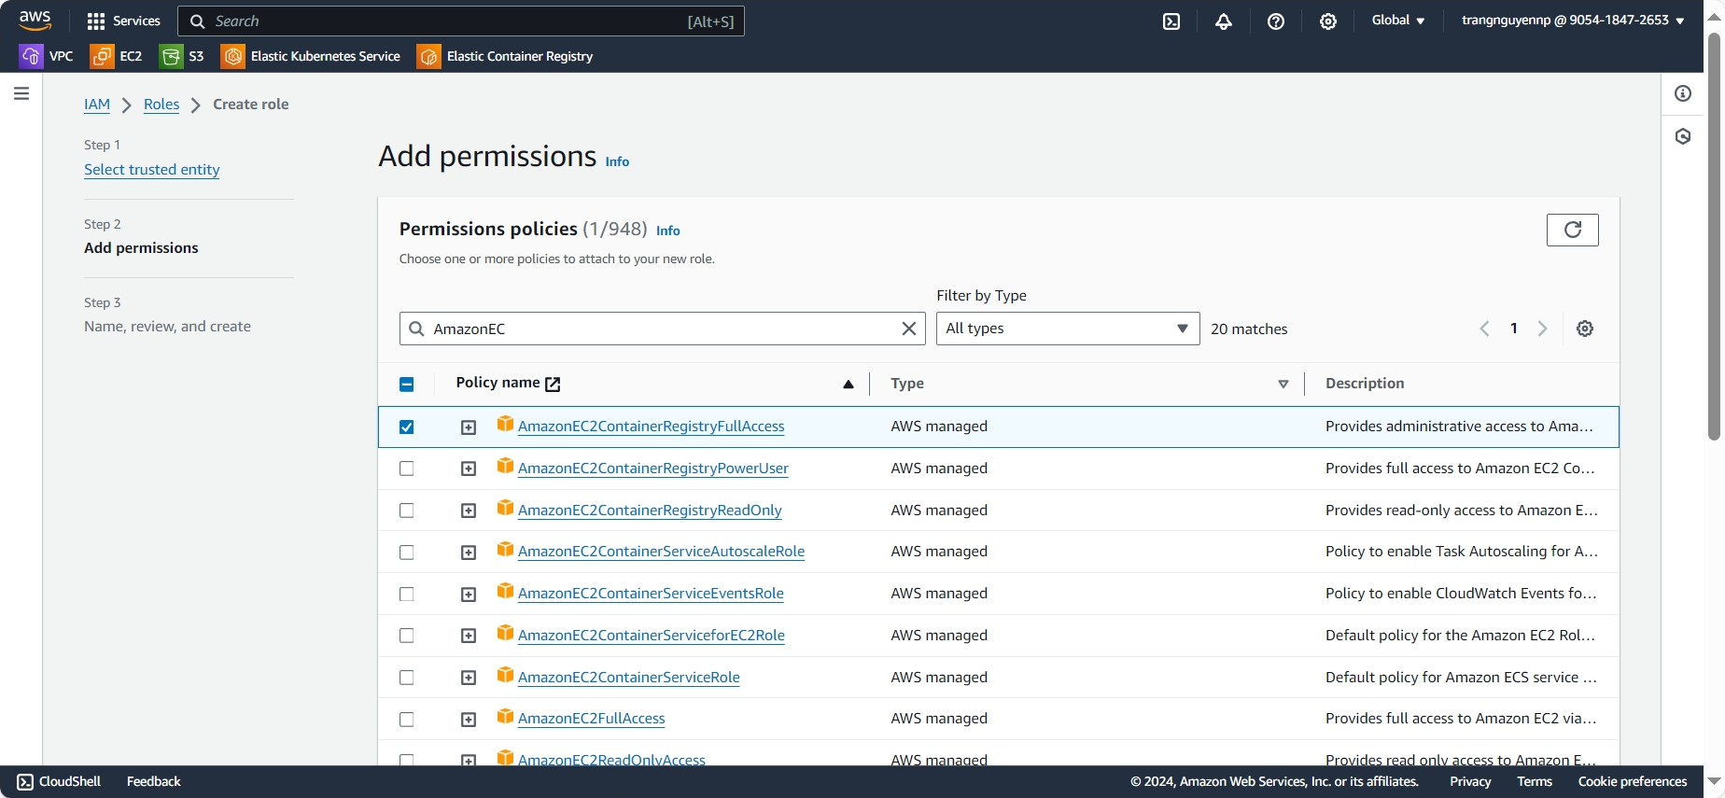

* Give a role name, review and click **Create role**.

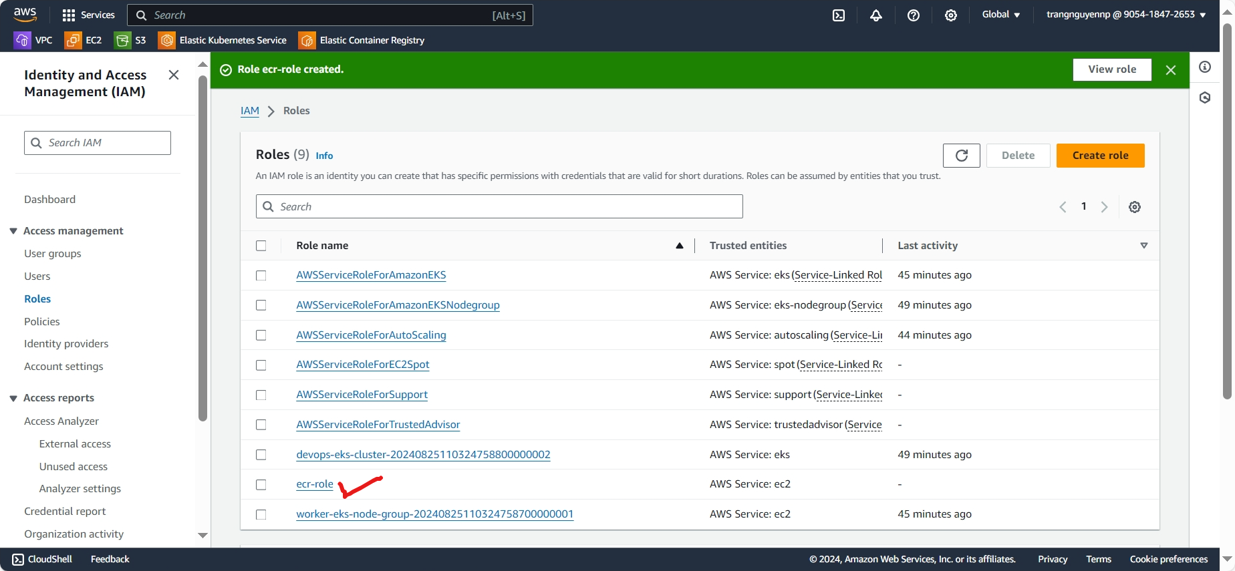

* Add AWS credential, go to the Manage Jenkins>>Credentials>>system>>Global credentials.

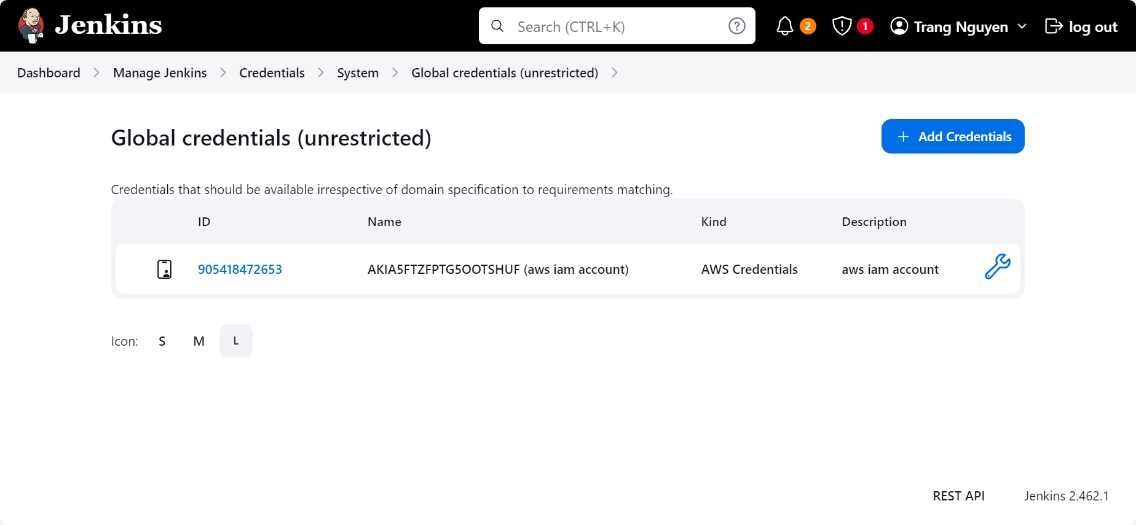

* Create Jenkins pipeline, go to the Jenkins dashboard then click on “**New Item**” and choose “**Pipeline**” from the options.

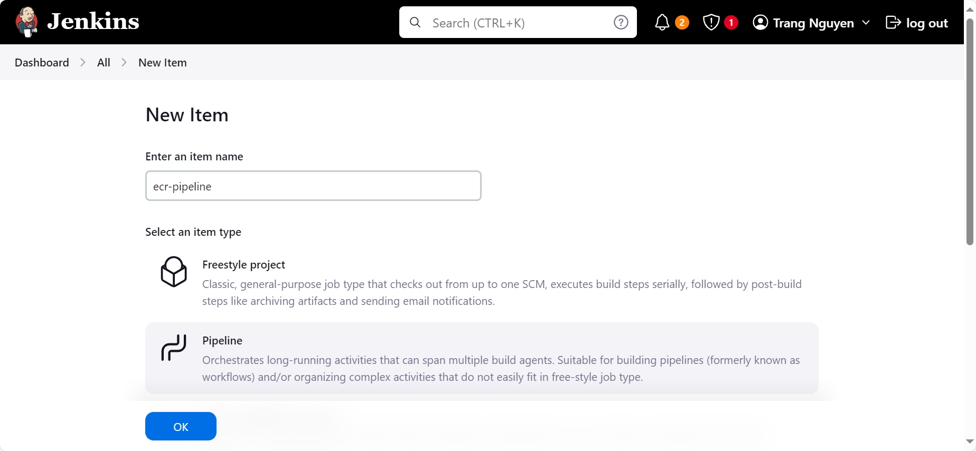

1. **EKS Setup**
2. **Monitoring with Prometheus and Grafana**